9.93: a) The initial moment of inertia is 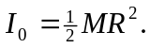 The piece punched has a mass of 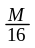 and a moment of inertia with respect to the axis of the original disk of

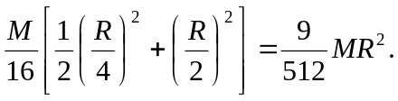

The moment of inertia of the remaining piece is then

